**Food Recommendation System**

Submitted in partial fulfillment of the requirements for the award of degree of

**BACHELOR OF ENGINEERING**

**IN**

**COMPUTER SCIENCE & ENGINEERING**



**Submitted to:**

**Ms. Manjot Kaur**

**Submitted By:**

**Yukta Sharma (17BCS1931)**

**Deepak Yadav (17BCS1993)**

**Ujawall Dwivedi (17BCS1947)**

**Utkarsh Singh (17BCS1954)**

**DEPARTMENT OF COMPUTER SCIENCE & ENGINEERING**

**Chandigarh University, Gharuan**

**CERTIFICATE**

This is to certify that the work embodied in this Project Report entitled **“Food Recommendation System”** being submitted by **“Yukta Sharma, Ujawall Dwivedi, Deepak Yadav and Utkarsh Singh ” -** UID **“17BCS1931,17BCS47,17BCS1991, 17BCS1954 ” ,** 7th Semester for partial fulfillment of the requirement for the degree of **“ Bachelor of Engineering in Computer Science & Engineering ”** discipline in “ **Chandigarh University** ” during the academic session Jan-Apr 2020 is a record of Bona fide piece of work, carried out by student under my supervision and guidance in the **“ Department of Computer Science & Engineering ”, Chandigarh University.**

**APPROVED & GUIDED BY:**

Er. Manjot Kaur

### DECLARATION

### I, student of Bachelor of Engineering in Computer Science & Engineering, 7th Semester , session: July – Dec 2021, Chandigarh University, hereby declare that the work presented in this Project Report entitled “Food Recommendation System ” is the outcome of my own work, is bona fide and correct to the best of my knowledge and this work has been carried out taking care of Engineering Ethics. The work presented does not infringe any patented work and has not been submitted to any other university or anywhere else for the award of any degree or any professional diploma.

**Student details and Signature**

Yukta Sharma (**17BCS1931**)

Ujawall Dwivedi **(17BCS1947)**

Deepak Yadav **(17BCS1993)**

Utkarsh Singh **(17BCS1954)**

**APPROVED & GUIDED BY:**

Er. Manjot Kaur

To our parents, teachers and all the well wishers out there . . .

**ABSTRACT**

People make decisions related to food every day. They all think about what to eat, where to eat, how much nutritional value this food has, can this make me lose weight, can this food make me healthy and other questions. Recommendation systems help the user to make fast decisions in these complex information spaces. The World Health Organization is predicting that the number of obese adults worldwide will reach 2.5 billion by 2018 and the issue is attracting increased attention. (WHO, 2010.) Much of this attention is being paid to diet management systems, which have been replacing traditional paper-and-pen methods. These systems include informative content and services, which persuade users to alter their behavior. Due to the popularity of these diet monitoring facilities, these systems hold a vast amount of user preference information, which could be harnessed to personalize interactive features and to increase engagement with the system and the diet program. One such personalized service, ideally suited to informing diet, is a food recommender. This recommender could exploit the nutritional values of the food to inform its recommendations. The domain of food centered here are milk and fish. These are taken as the main ingredients. Almost all of the foods, that include either of these as a main ingredient is taken into consideration. Other factors include the nutritional breakdown, as well as the Food recommendation system using content-based filtering algorithm 2 cultural and social factors. Add this to the sheer number of foods and the fact that eating often happens in groups, the complexity of the challenge is clear. This recipe recommendation application can help the user to find their favorite food and its nutritional value. This is done by searching the foods that contain one of the prime ingredients and shows their nutritional value.

**TABLE OF CONTENTS**

**Introduction1**

Data Flow Diagram4

System Design5

**Feasibility Analysis7**

Configuration8

**Software Interface9**

**Software Design16**

Input Design17

Input Data17

**Output Design18**

**Database Design19**

**System Implementation20**

**System Testing22**

**Conclusion23**

**Bibliography24**

**INTRODUCTION**

Nutrients through diet are essential for body composition and healthy functioning of the body. In particular, the growth status of children is an important indicator of nutritional status because the exposed nutritional environment affects genetic growth potential. Since childhood is a time of formation of self, it is important to help them have right and healthy habit. A well-balanced diet habit of a wide variety of foods and adequate nutrition can help to maintain proper growth and healthy life for infants. The biggest problem of dietary status of young children is unbalanced, and the most common reason was unfamiliar taste.

Shim et. conducted the study to investigate the association between picky eating behaviours of preschool children and growth outcomes. They defined picky eating behaviours as the four constructs: eating a small amount (ES), neophobic behaviour (NB), refusal of specific food groups (RF), and preference for specific food preparation methods (PP). Children with ES had lower height for age and weight for height than those without ES. In particular, picky eating of ES showed a risk of faltering height growth in preschool children.

Early childhood education institutions in Korea are divided into childcare facilities and kindergartens. Childcare facilities are targeted for pre-schoolers under 6 years of age (Childcare Act 2004). Kindergartens are aimed at children from 3 years of age to pre-schoolers (Early Childhood Education Act 2004). At present, most childcare facilities and kindergartens provide one or more meals and two or more snacks to the children. Since young children spend more than 35 hours per week in the aforementioned institutions, they will eat lunch and snacks at the same place. This means that their parents as well as the institutions make the children’s weekday meals. For this reason, it is necessary to manage their meals at the institutions.

It is not easy to know how much food a young child ate every day. In this paper, we came up with the idea that young children aged 3 to 5 years carry their plates in their bags when they go to a kindergarten (or childcare facility). Young children eat lunch in kindergarten using their own plates. The children’s standard plate is designed to hold food in five places, as shown in Figure [1](https://www.hindawi.com/journals/wcmc/2019/7971381/fig1/). In other words, by using a smart plate that weighs, we not only know the food intake of a young child but also the nutritional intake. Based on this, it can provide food recommendation services that identify the nutritional deficiencies and correct their eating habits.

**Purpose**

The purpose is to design a website which would recommend you food incase you’re in jiffy about what to eat.

**Objectives**

• Providing the online interface for food ordering.

• Increasing the efficiency during food ordering.

• Decrease time required to choose a meal to eat..

• To make the system more secure.

• Decrease time spent on non-value-added tasks.

**DATA FLOW DIAGRAM**

A Data Flow Diagram (DFD) is a graphical representation of the “flow” of Student Information System. A data flow diagram can also be used for the visualization of Data Processing]. DFD shows the interaction between the system and outside entities. This context-level DFD is then “exploded” to show more detail of the system being modelled. A DFD represents flow of data through a system. Data flow diagrams are commonly used during problem analysis. It views a system as function that transforms the given input into required output. Movement of data through the different transformations or processes in the system are shown in Data Flow Diagram of Fig. 1.

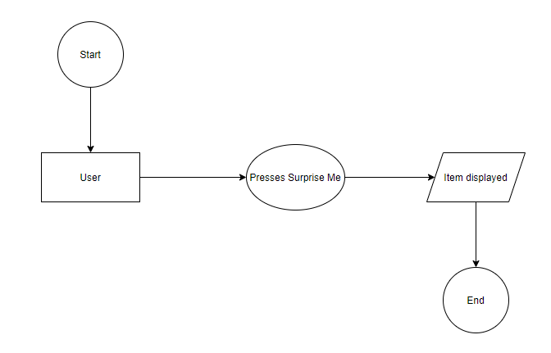

**Fig 2. Level 0 DFD**

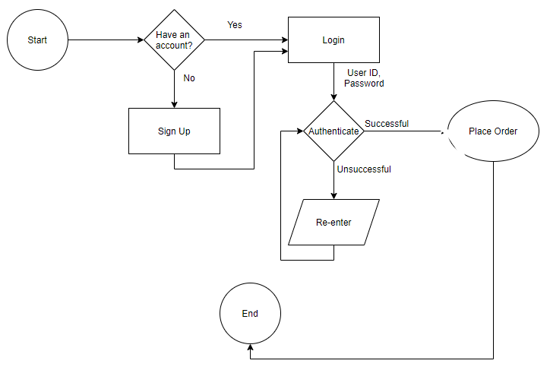

**Fig 3. Level 1 DFD**

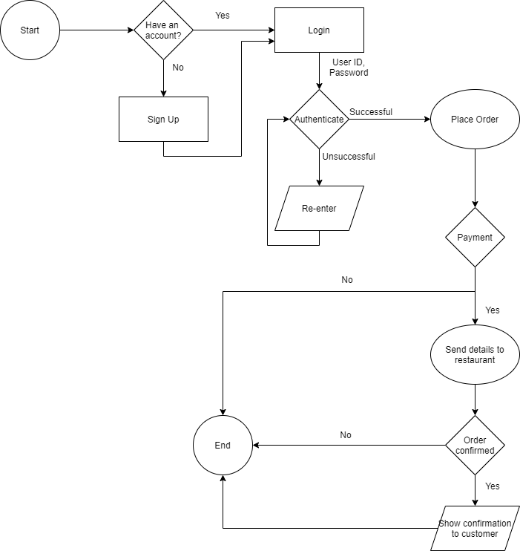

**SYSTEM ANALYSIS**

**EXISTING SYSTEM:**

System Analysis is a detailed study of the various operations performed by a system and their relationships within and outside of the system. Here the key question is- what all problems exist in the present system? What must be done to solve the problem? Analysis begins when a user or manager begins a study of the program using existing system.

During analysis, data collected on the various files, decision points and transactions handled by the present system. The commonly used tools in the system are Data Flow Diagram, interviews, etc. Training, experience and common sense are required for collection of relevant information needed to develop the system. A good analysis model should provide not only the mechanisms of problem understanding but also the frame work of the solution. Thus, it should be studied thoroughly by collecting data about the system. Then the proposed system should be analyzed thoroughly in accordance with the needs.

System analysis can be categorized into four parts.

* System planning and initial investigation
* Information Gathering
* Applying analysis tools for structured analysis
* Feasibility study
* Cost/ Benefit analysis.

In the current system we need to keep a number of records of the order history of the user which could help in giving better recommendations.

**PROPOSED SYSTEM:**

In our proposed system we have the provision for getting recommendations even without logging in. So, the server load becomes less. However, it is essential to have an account and to be logged in incase you need to order from a restaurant.

Our proposed system has several advantages

* User friendly interface
* Fast access to database
* Less error
* More Storage Capacity
* Search facility
* Look and Feel Environment
* Quick transaction

All the manual difficulties in managing the user details in a database have been rectified by implementing computerization.

**FEASIBILITY ANALYSIS**

Whatever we think need not be feasible. It is wise to think about the feasibility of any problem we undertake. Feasibility is the study of impact, which happens in the organization by the development of a system. The impact can be either positive or negative. When the positives nominate the negatives, then the system is considered feasible. Here the feasibility study can be performed in two ways such as technical feasibility and Economical Feasibility.

**TECHNICAL FEASIBILITY:**

We can strongly say’s that it is technically feasible, since there will not be much difficulty in getting required resources for the development and maintaining the system as well. All the resources needed for the development of the software as well as the maintenance of the same is available in the organization here we are utilizing the resources which are available already.

**ECONOMIC FEASIBILITY:**

Development of this application is highly economically feasible. The organization needed not spend much money for the development of the system already available. The only thing is to be done is making an environment for the development with an effective supervision. If we are doing so, we can attain the maximum usability of the corresponding resources. Even after the development, the organization will not be in condition to invest more in the organization. Therefore, the system is economically feasible.

**CONFIGURATION**

**HARDWARE CONFIGURATION:**

|  |  |  |
| --- | --- | --- |
| Processor | : |  |
| RAM | : | 1GB |
| Hard Disk | : | 50GB |
| Monitor | : |  |
| Key Board | : |  |

**SOFTWARE CONFIGURATION:**

Operating System

Language

Database

: Windows 8.1, Linux

: HTML, CSS, PHP, JavaScript

: MySQL

**SOFTWARE INTERFACE**

**Login**

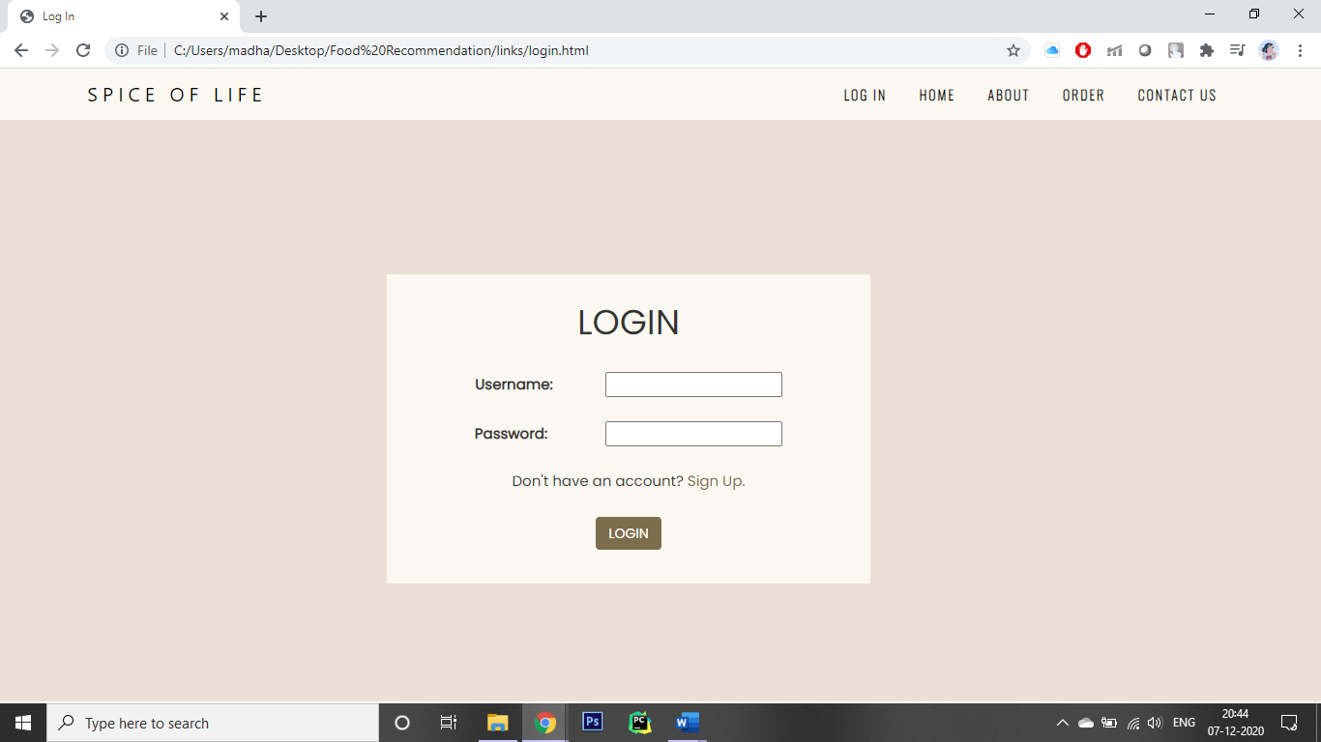

**Sign Up**

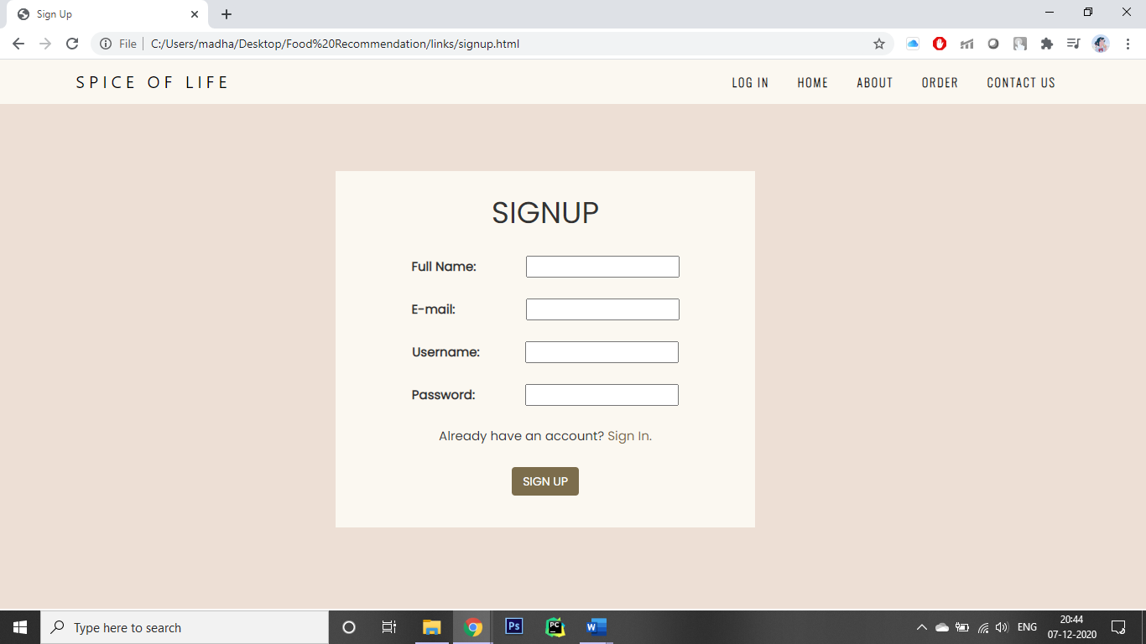

**Home**

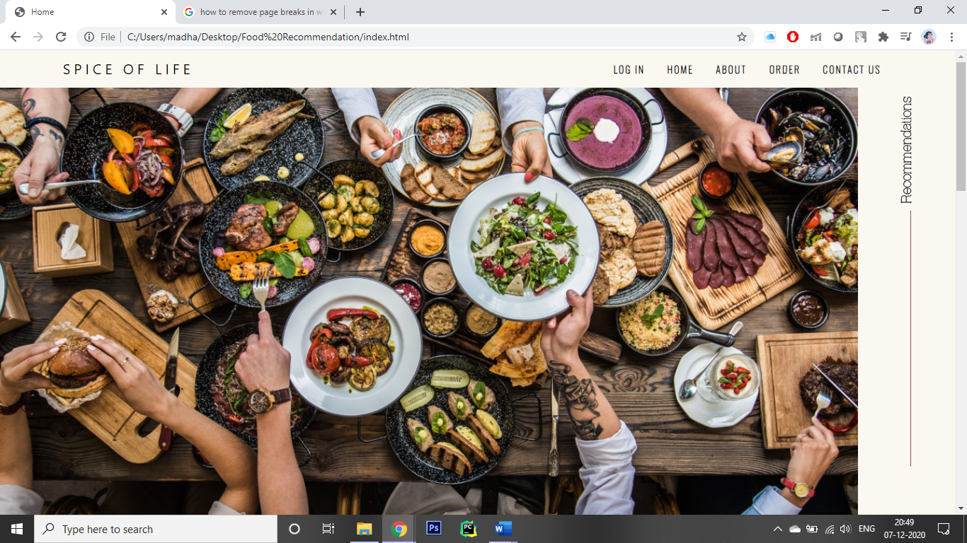

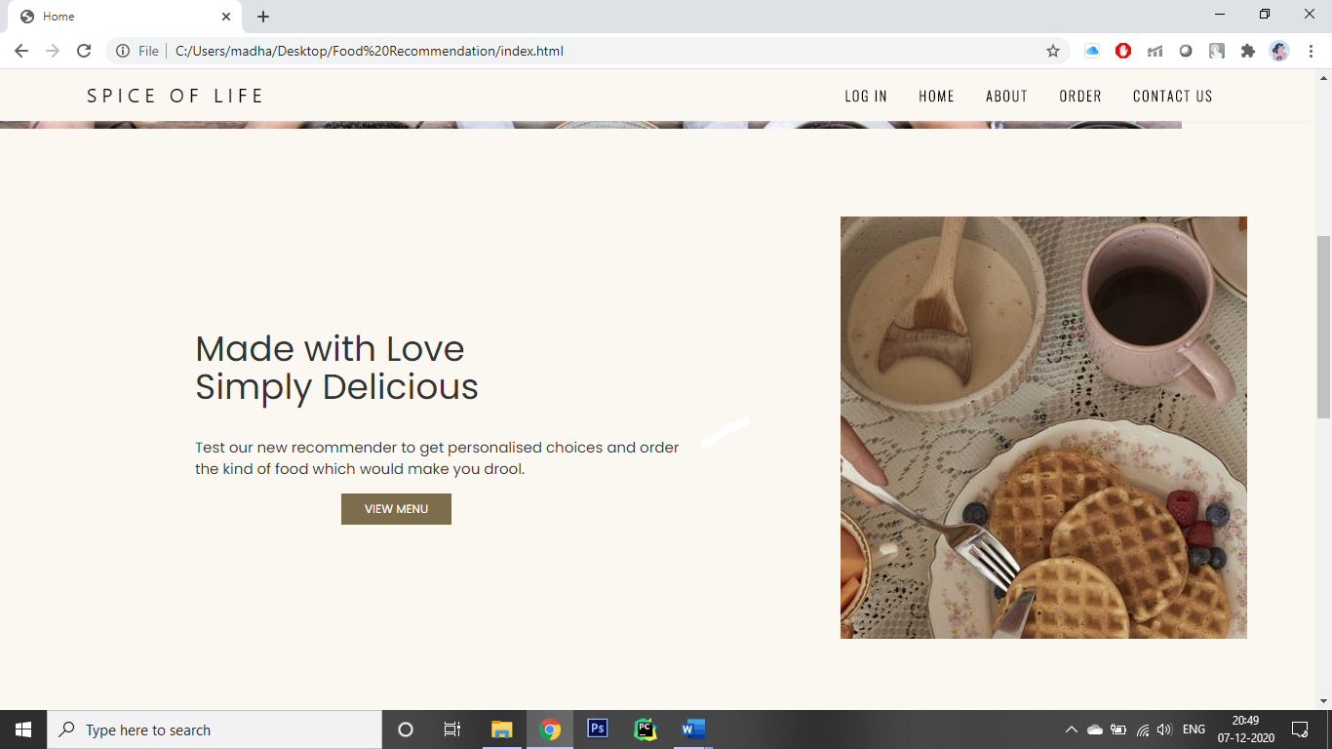



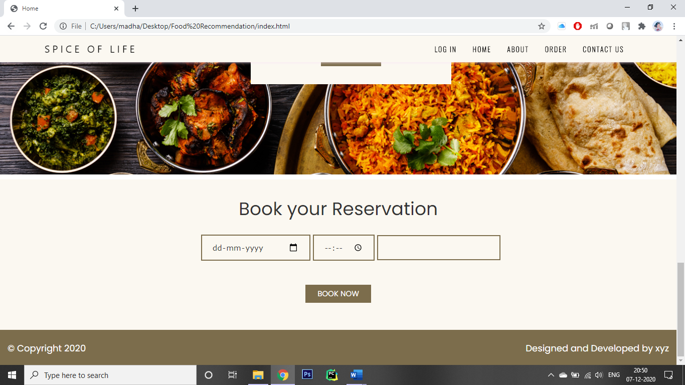

**About**

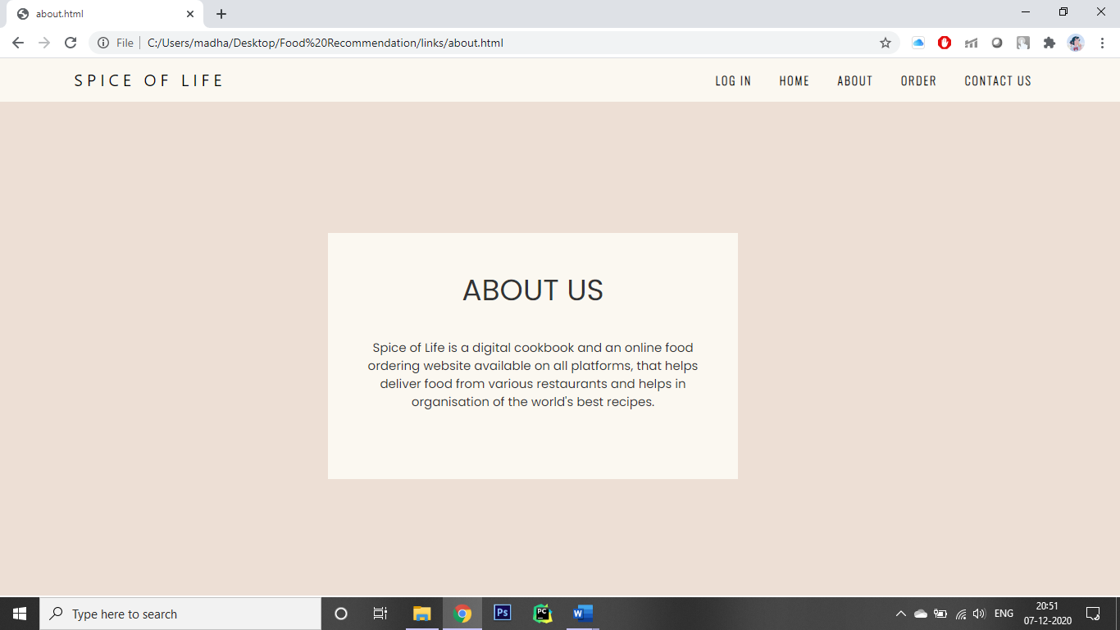

**Contact**

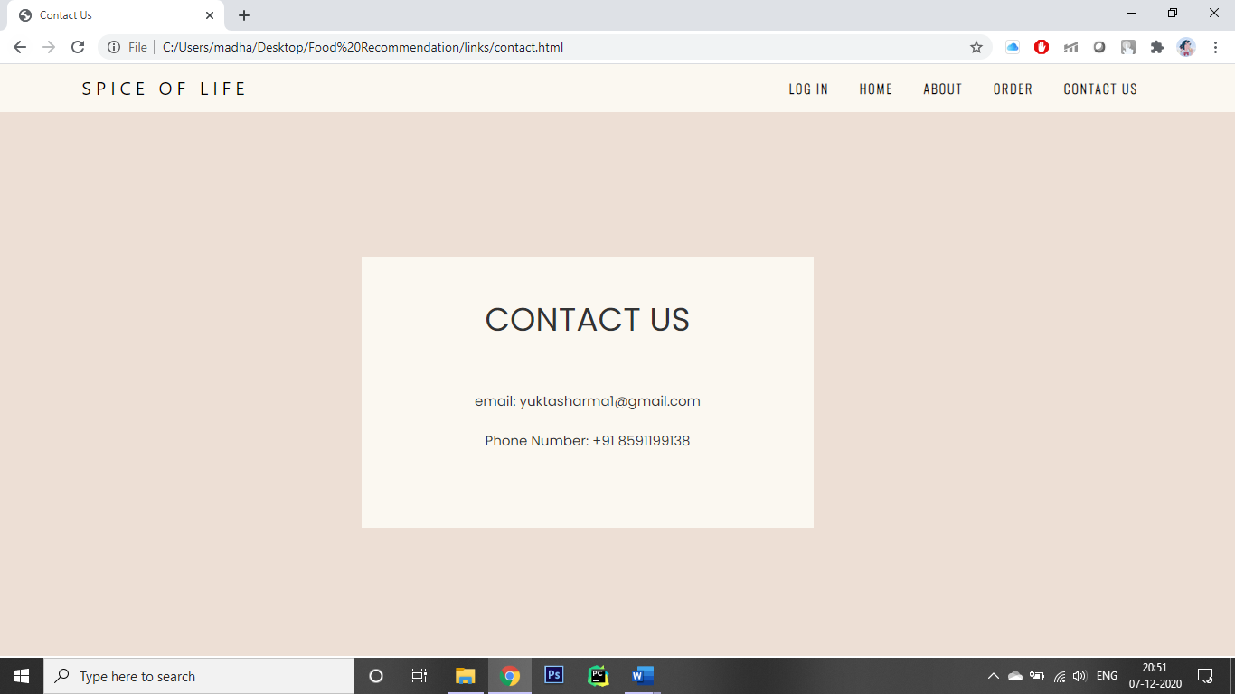

**Menu**

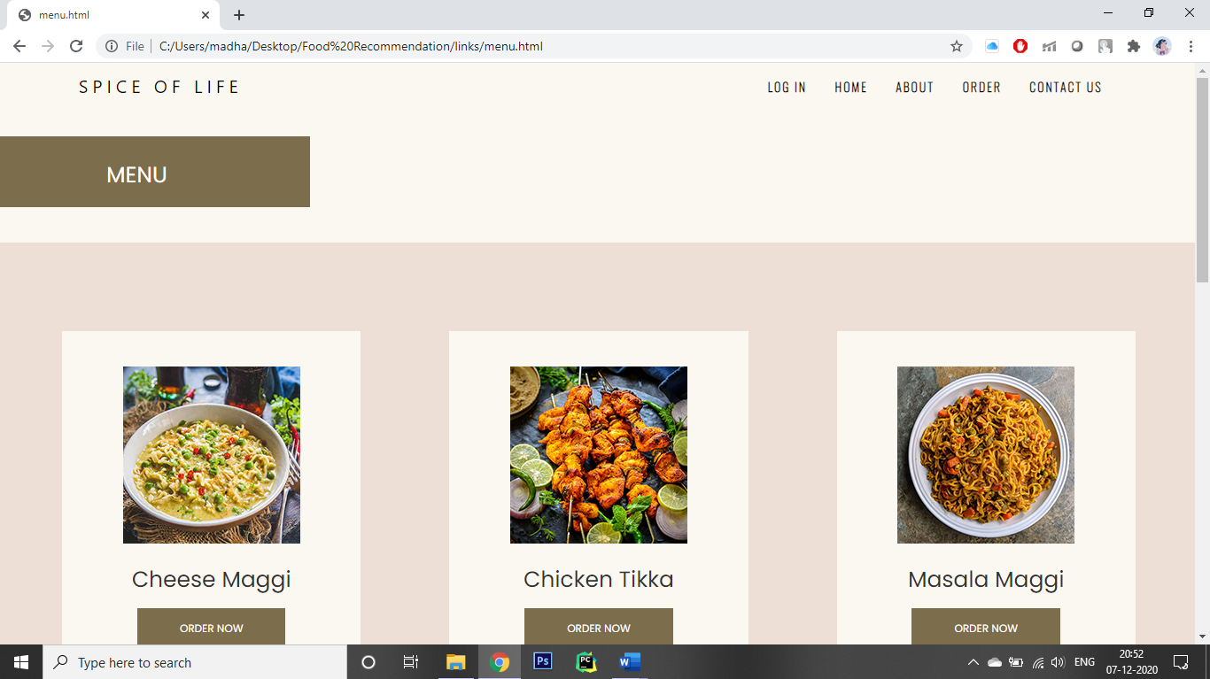

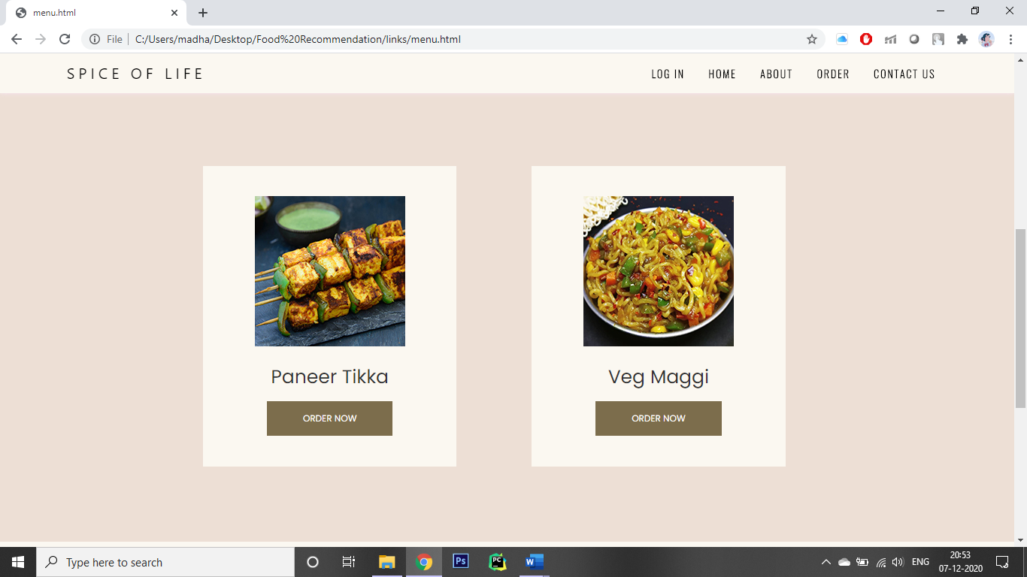

**Recommender**

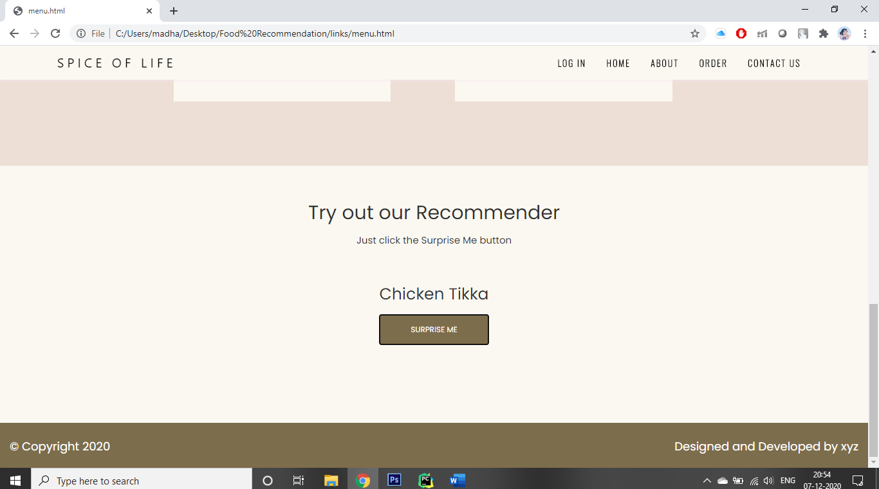

**SYSTEM DESIGN**

**INPUT DESIGN**

Input design is the process of converting user-oriented input to a computer based format. Input design is a part of overall system design, which requires very careful attention. Often the collection of input data is the most expensive part of the system. The main objectives of the input design are …

1. Produce cost effective method of input
2. Achieve highest possible level of accuracy
3. Ensure that the input is acceptable to and understood by the staff.

**INPUT DATA:**

The goal of designing input data is to make entry easy, logical and free from errors as possible. The entering data entry operators need to know the allocated space for each field; field sequence and which must match with that in the source document. The format in which the data fields are entered should be given in the input form. Here data entry is online; it makes use of processor that accepts commands and data from the operator through a key board. The input required is analyzed by the processor. It is then accepted or rejected. Input stages include the following processes

* Data Recording
* Data Transcription
* Data Conversion
* Data Verification
* Data Control
* Data Transmission
* Data Correction

One of the aims of the system analyst must be to select data capture method and devices, which reduce the number of stages so as to reduce both the changes of errors and the cost. Input types, can be characterized as.

* External
* Internal
* Operational
* Computerized
* Interactive

Input files can exist in document form before being input to the computer. Input design is rather complex since it involves procedures for capturing data as well as inputting it to the computer.

**OUTPUT DESIGN**

Outputs from computer systems are required primarily to communicate the results of processing to users. They are also used to provide a permanent copy of these result for latter consultation. Computer output is the most important and direct source of information to the users. Designing computer output should proceed in an organized well through out the manner. The right output must be available for the people who find the system easy o use. The outputs have been defined during the logical design stage. If not, they should have defined at the beginning of the output designing terms of types of output connect, format, response etc.

Various types of outputs are

* External outputs
* Internal outputs
* Operational outputs
* Interactive outputs
* Turn around outputs

All screens are informative and interactive in such a way that the user can full fill his requirements through asking queries.

**DATABASE DESIGN**

The general theme behind a database is to handle information as an integrated whole. A database is a collection of interrelated data stored with minimum redundancy to serve many users quickly and effectively. After designing input and output, the analyst must concentrate on database design or how data should be organized around user requirements. The general objective is to make information access, easy quick, inexpensive and flexible for other users. During database design the following objectives are concerned: -

* Controlled Redundancy
* Data independence
* Accurate and integrating
* More information at low cost
* Recovery from failure
* Privacy and security
* Performance
* Ease of learning and use

**SYSTEM IMPLEMENTATION**

Implementation is the stage in the project where the theoretical design is turned into a working system. The implementation phase constructs, installs and operates the new system. The most crucial stage in achieving a new successful system is that it will work efficiently and effectively.

There are several activities involved while implementing a new project. They are

* End user training
* End user Education
* Training on the application software
* System Design
* Parallel Run and To New System
* Post implementation Review

**End user Training:**

The successful implementation of the new system will purely upon the involvement of the officers working in that department. The officers will be imparted the necessary training on the new technology.

**End User Education:**

The education of the end user start after the implementation and testing is over. When the system is found to be more difficult to understand and complex, more effort is put to educate the end used to make them aware of the system, giving them lectures about the new system and providing them necessary documents and materials about how the system can do this.

**Training of application software:**

After providing the necessary basic training on the computer awareness, the users will have to be trained upon the new system such as the screen flows and screen design type of help on the screen, type of errors while entering the data, the corresponding validation check at each entry and the way to correct the data entered. It should then cover information needed by the specific user or group to use the system.

**Post Implementation View:**

The department is planning a method to know the states of the past implementation process. For that regular meeting will be arranged by the concerned officers about the implementation problem and success.

**SOFTWARE TESTING**

Is the menu displayed in the appropriate contested some system related features included either in menus or tools? Do pull –Down menu operation and Tool-bars work properly? Are all menu function and pull-down sub function properly listed; Is it possible to invoke each menu function using a logical assumption that if all parts of the system are correct, the goal will be successfully achieved. In adequate testing or non-testing will leads to errors that may appear few months later.

This create two problems

* 1. Time delay between the cause and appearance of the problem.

1. The effect of the system errors on files and records within the system

The purpose of the system testing is to consider all the likely variations to which it will be suggested and push the systems to limits.

The testing process focuses on the logical intervals of the software ensuring that all statements have been tested and on functional interval is conducting tests to uncover errors.

**CONCLUSION**

Our project is only a humble venture to satisfy the needs of an individual. Several user-friendly coding has also been adopted. This package shall prove to be a powerful package in satisfying all the requirements of the organization.

The objective of software planning is to provide a frame work that enables the manger to make reasonable estimates made within a limited time frame at the beginning of the software project and should be updated regularly as the project progresses. Last but not least it is no the work that played the ways to success but **ALMIGHTY**

**BIBLIOGRAPHY:**

1. <https://www.w3schools.com/html/>
2. https://www.w3schools.com/php/default.asp